**EU4 Save Stats**

Technical Design Document

MSCS 621L Cloud Computing

Marist University

School of Computer Science and Mathematics

Frank Seelmann

May 7th, 2025

# Project Overview

The EU4 Save Stats (EUSS) project a web-based dashboard for viewing information from Europa Universalis IV (EU4) save game files. Users can upload their save files to the service, which will then process the file to extract relevant data, store it in a database, and display that information through a web interface. The raw save file is also saved after processing, so that the file can be re-processed if new parsing features are added. Users can also add friends so that they view each other’s their save-game data or share individual save-file data with other users who are not their friend. The project utilizes AWS services, including EC2 for processing, a database for storing extracted data, and an S3 bucket for storing the raw save files.

## Scope

Europa Universalis 4 is a complicated grand strategy game. Consequently, there is a *ton* of data that can be gleaned from the save files. To complete the project on time, it was important to define the scope of the project ahead of time to avoid spending too much time developing the wrong aspects of the project.

* **In Scope:**
  + User authentication and file upload system.
  + Parsing and processing Europa Universalis IV save files.
  + Data storage and querying functionality.
  + Web-based dashboard for data visualization.
  + Integration with AWS (EC2, S3, Database).
  + Multiplayer game analytics.
* **Out of Scope:**
  + Modding support or custom game rule tracking.
  + Compressed save files (“Ironman” campaigns)
  + Advanced AI-based predictions or advice

# Project Overview

The primary objectives of the EU4 Save Stats project are centered around building a scalable and user-friendly platform for analyzing Europa Universalis IV save files. The system enables users to upload their save files, which are processed by a rust-based executable. To help with this, an existing Rust-based parser library, eu4save [1], to extract relevant gameplay data. This extracted data will be stored in a structured database to support efficient querying and retrieval.

To make the data actionable and insightful, a web-based dashboard visualizes key metrics, such as annual income by year, the date where certain events occurred, the current balance, and the current manpower reserves.

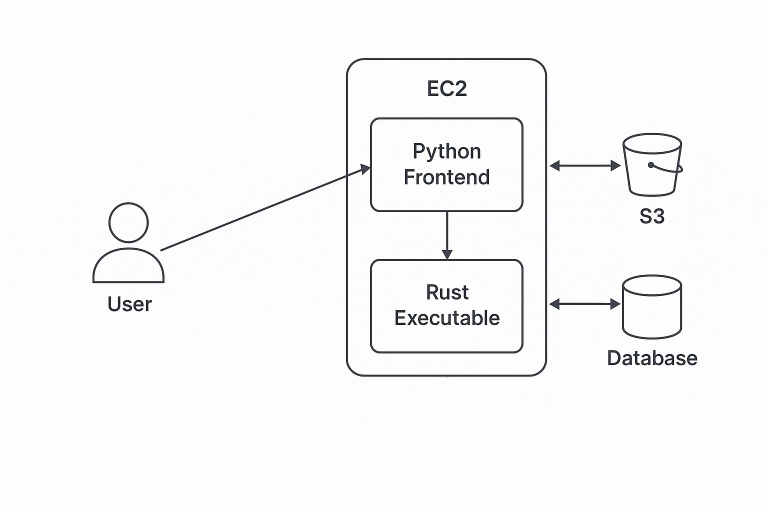For infrastructure, the project leverages Amazon Web Services to ensure scalability and reliability. An EC2 instances handles the webserver via Python’s Flask library, and the processing of save files with a Rust executable. The database service is used to store extracted data for querying from the frontend, and S3 is used to retain the original save files for future reference, such as if new parsing features get added. The following image was generated by providing the section above to ChatGPT:

Figure 1 – High Level Architecture [2]

The website also features user accounts with sign-up and login functionality. Uploaded files are associated with the respective user, and a social feature allows users to add friends and view each other’s save file data through the dashboard. There is also a forum area for users to provide feedback/ask questions.

## Technologies & Tools

The following is an outline of the different programming languages, utilities, and libraries that will be used in the EUSS project:

* **Source Code Repository**: GitHub, [Frank-Seelmann/EU4SaveStats](https://github.com/Frank-Seelmann/EU4SaveStats) [3]
* **Frontend:** Python – Flask Library (for dashboard UI)
* **Backend:** Rust (for save file processing)
* **Database:** MySQL RDS Database, mounted to the EC2 instance
* **Cloud Services:** AWS EC2, S3, and RDS
* **File Processing:** eu4save Rust library
* **Development:** Initially, Docker was used to compile the Rust program for AWS Linux on the Windows development computer, since compiling it in the EC2 instance used more resources than is available in the free tier “micro” instance. Later, a GitHub CI/CD was used instead to compile the code for Linux.

# Usage

This section will include screenshots of the project’s features. Upon arriving at the site, users are first prompted to sign in:

Or instead register if they would like to create a new account. There is some simple checking in the form that the Username is 4 characters or longer, that the email is of a valid format, and that the password is 6 characters or longer.

Once logged in, the user can see their username in the top right corner, all the files they’ve uploaded, and the files shared with them by other users. At the bottom the user can choose to upload a new save file. Selecting the box above the Upload button will automatically share the file with all other users who are friends of the user.

Once uploaded, the user is taken to a page to view the data from the file (same as clicking the “View” for action for a previously uploaded file. Here the file can be shared with other users (even if they are not friends with the user), and view the data extracted from the file. All tables are sortable and searchable.

Clicking on the “Friends” button in the navbar brings the user to a page to send friend requests to other users, accept friend requests, and view their friends list.

Clicking the “Forum” button brings the user to the forum section. Topics can be created, and users can make posts within them. Only the user who created a topic/post is allowed to delete it.

# Future of the Project

Through the development process done so far, the backend infrastructure has been established. Further development could be made in enhancing the frontend data viewing experience with additional data analysis. Also, there is plenty more data to be extracted from the save file; what is currently included is just the most important information. Finally, a more involved feature would be adding the ability to view information of multiple save files from the same campaign together. Unfortunately, not all the data is stored over time, and is only relevant to the in-game date the save was taken. Stringing multiple of these saves together could provide interesting information, though it would require the user to be proactive with how often they save the game.

# References

[1] <https://github.com/rakaly/eu4save>

[2] <https://chatgpt.com/>

[3] <https://github.com/Frank-Seelmann/EU4SaveStats>